

American International University-Bangladesh (AIUB)  
Department of Computer Science  
Faculty of Science &Technology (FST)  
Spring 23-24

Section: J  
Software Quality Assurance and Testing

A web application of: Healthcare Portal System

A Report submitted

By

|  |  |  |
| --- | --- | --- |
| SN | Student Name | Student ID |
| 1 | Tousif Islam | 17-33601-1 |
| 2 | Zarin Tasnim Rayta | 21-45742-3 |
| 3 | Shoaib Ahamed | 18-37821-2 |

**Checked By Industry Personnel**

Name:

Designation:

Company:

Sign:

Date:

Software Test Plan

for

<Healthcare Portal System>

Version 1.0 approved

Prepared by < Tousif Islam, Zarin Tasnim Rayta, Shoaib Ahamed >

< American International University Bangladesh>

<22 April 2024>

Table of Contents

Revision History 3

1. TEST PLAN IDENTIFIER: RS-MTP01.3 4

2. REFERENCES 4

3. INTRODUCTION 4

Background to the Problem 4

Solution to the Problem 4

4. REQUEIREMNT SPECIFICATION 5

4.1 System Features 5

4.2 System Quality Attributes 8

4.3 System Interface 9

4.4 Project Requirements 9

5. FEATURES NOT TO BE TESTED 10

6. TESTING APPROACH 10

6.1 Testing Levels 10

6.2 Test Tools 11

6.3 Meetings 11

7. TEST CASES/TEST ITEMS 12

8. ITEM PASS/FAIL CRITERIA 13

9. TEST DELIVERABLES 36

10. STAFFING AND TRAINING NEEDS 37

11. RESPONSIBILITIES 37

12. TESTING SCHEDULE 38

13. PLANNING RISKS AND CONTINGENCIES 38

14. APROVALS 39

# Revision History

|  |  |  |  |
| --- | --- | --- | --- |
| Revision | Date | Updated by | Update Comments |
| 0.1 | 2024.04.17 | Tousif Islam | First Draft |
| 0.2 | 2024.04.23 | Shoaib Ahamed | Final Modified Draft |
|  |  |  |  |
|  |  |  |  |
|  |  |  |  |
|  |  |  |  |
|  |  |  |  |
|  |  |  |  |
|  |  |  |  |

# TEST PLAN IDENTIFIER:RS-MTP01.3

# REFERENCES

* Software Testing and Quality Assurance – Theory and Practice - Kshirasagar Naik & Priyadarshi Tripathy
* https://www.selenium.dev/selenium-ide/docs/en/introduction/getting-started

# INTRODUCTION

## Background to the Problem

The healthcare industry is rapidly adopting digital solutions to improve patient care, streamline administrative processes, and enhance overall efficiency. With the increasing reliance on technology in healthcare, there is a growing need for robust and reliable healthcare management websites that can effectively manage patient data, facilitate communication among healthcare professionals, and provide seamless access to medical information and services.

## Solution to the Problem

* The proposed solution is to develop a comprehensive healthcare management website that meets the evolving needs of the healthcare industry. This website will be designed to ensure the efficient management of patient records, appointment scheduling, medical billing, and other essential healthcare processes. By implementing a user-friendly interface and robust backend systems, the website aims to enhance the overall healthcare experience for both patients and healthcare providers
* The purpose of the healthcare management website is to provide a centralized platform for healthcare professionals to manage patient information, streamline administrative tasks, and improve the overall quality of care. Additionally, the website aims to enhance patient engagement by offering features such as secure messaging, appointment reminders, and access to personalized health information
* Several existing software solutions in the healthcare industry offer insights into best practices for designing and testing healthcare management websites. These solutions include electronic health record (EHR) systems, practice management software, and telemedicine platforms. By leveraging the lessons learned from these existing solutions, the proposed healthcare management website can benefit from proven strategies and methodologies.

# REQUEIREMNT SPECIFICATION

## System Features

1. Login

Functional Requirements

1. The software shall allow users to login with their given username and password.
2. If the username and/or password has been inserted wrong for more than three times, the random verification code will be generated by the system to retry login.
3. If the number of login attempt exceed its limit (5 times), the system shall block the user account login for one hour

Priority Level: High

Precondition: User have valid user id and password

1. Signup

Functional Requirements

1. The software shall provide a user registration feature for individuals to create an account on the healthcare portal.
2. Users shall be required to provide essential information such as full name, date of birth, gender, contact information, and a valid email address.
3. The system shall enforce secure password policies, including a minimum length, the inclusion of alphanumeric characters, and special characters.

Priority Level: High

Precondition: User must sign up if no valid username and password

1. Available list

Functional Requirements

1. The system shall display the doctor's availability, including regular working hours and days.
2. The system should indicate if a doctor is currently accepting new patients or if they have specific appointment slots available.

Priority Level: Medium

Precondition: User must sign in with valid username and password.

1. Make the Appointments of doctor

Functional Requirements

1. The system shall allow users to schedule appointments with healthcare professionals.
2. Users should be able to select a preferred date and time for the appointment.
3. The system shall provide a calendar interface for users to view available appointment slots.

Priority Level: Low

Precondition: User have to login to the system and select doctor as per appointment.

1. Request for the necessary service

Functional Requirements

1. The system shall provide a user-friendly interface for users to submit service requests.
2. Users shall be able to specify the type of healthcare service they are requesting (e.g., medical consultation, diagnostic tests, home care).
3. The service request form shall include fields for relevant details, such as the reason for the request, preferred date and time, and any specific requirements.

Priority Level: Medium

Precondition: User have to check the availability of service.

1. Payment history

Functional Requirements

1. The system shall maintain a comprehensive and easily accessible payment history for each user.
2. Users should be able to view their past payment transactions, including details like date, amount, purpose, and transaction status.

Priority Level: High

Precondition: User have to appointment or booking the slot.

1. Complain box

Functional Requirements

1. The system shall provide a user-friendly interface for users to submit complaints regarding any uncertain situations or issues encountered within the healthcare portal.
2. Users shall have the option to attach supporting documents, screenshots, or other relevant files to provide additional context to their complaints.
3. Users and administrators shall be able to track the status of submitted complaints, indicating whether they are pending, in progress, or resolved.

Priority Level: Low

Precondition: The complainant must be an existing patient with a valid and active record in the healthcare portal system.

1. Medicine

Functional Requirements

1. The software shall provide a search feature allowing users to find medicines by entering keywords, generic names, or brand names.
2. Users should be able to search for medicines prescribed by a specific doctor.
3. The system shall indicate the current availability status of each medicine, including whether it is in stock or out of stock.

Priority Level: Medium

Precondition: User have to appointment to doctor.

1. Transaction history

Functional Requirements

1. The system shall provide users with the ability to view a detailed transaction history related to their healthcare portal account.
2. The transaction history shall include information such as transaction date and time, type of transaction, and transaction amount.

Priority Level: High

Precondition: User can view the history about the whole transaction.

1. Contact with healthcare

Functional Requirements

1. The system shall provide authorized healthcare professionals with access to patient information, including but not limited to medical history, current medications, allergies, and contact details.
2. The portal shall support the secure transfer of health records between different healthcare providers to ensure continuity of care.

Priority Level: Low

Precondition: To access the transfer money and transaction history features.

1. Review system

Functional Requirements

1. The system shall allow registered users to submit reviews for healthcare services.
2. Users should be able to provide ratings (e.g., star ratings) for the overall service quality.
3. Users shall have the option to write detailed comments describing their experience with the healthcare service.

Priority Level: Low

Precondition: Users must have an authenticated account to submit reviews.

1. Logout

Functional Requirements

1. The software shall provide a secure logout functionality for users to terminate their active session within the healthcare portal system.
2. The system shall automatically log out users after a specified period of inactivity to ensure security and privacy.
3. The system shall display a logout confirmation message to the user, indicating that the logout process was successful.

Priority Level: High

Precondition: Need to login first.

## System Quality Attributes

**Security:**

* Patient data must be securely stored and transmitted.
* Access to sensitive information should be restricted based on user roles and permissions.
* Implement encryption protocols to protect data integrity.

**Privacy:**

* Ensure compliance with healthcare privacy regulations.
* Patient consent mechanisms for data sharing.
* Anonymize or pseudonymize data when appropriate.

**Reliability:**

* The system should be available for use 24/7, with minimal downtime.
* Implement backup and recovery mechanisms for critical data.
* Real-time monitoring for system health and performance.

**Accuracy:**

* Ensure accurate storage and retrieval of patient records.
* Implement validation checks for data input to prevent errors.
* Use reliable sources for medical information and updates.

**Interoperability:**

* Support integration with electronic health records (EHR) systems.
* Enable communication with other healthcare systems and databases.
* Adhere to industry standards for data exchange.

**Usability:**

* Provide an intuitive user interface for healthcare professionals and patients.
* Streamline navigation for quick access to relevant information.
* Support accessibility standards for users with disabilities.

**Scalability:**

* Design the system to handle a growing number of users and data.
* Ensure that performance remains optimal as the system scales.
* Plan for future expansion of services and features.

**Adaptability:**

* Accommodate changes in medical practices and protocols.
* Allow for customization to meet the specific needs of different healthcare

## System Interface

* Here are the some important of interfaces about Healthcare Portal System



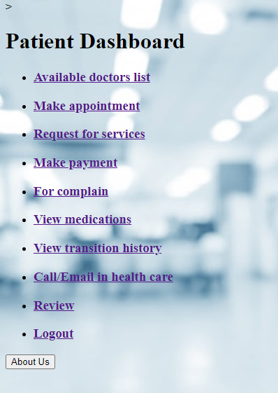

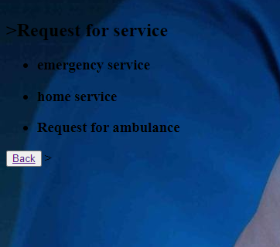

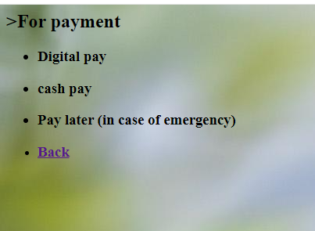

## Project Requirements

If the project Duration is four months. Then we have to identify the overall budgets. As we have the two front end developer so each salary is 20,000 and we have three backend developer with salary of 30,000. The project manager has 60,000. One Junior SQA engineers with 15,000 salary. Two senior tester with salary of 45,000. As the budget will be ,

[(2*20,000)+(3*30,000)+(1*60,000)+(1*15,000)+(2*45,000)]*4

* 11,80,000

But, Utility and transportation cost will be added. In that case , we assume the in total extra bill will be 50,000. Then the budget will be [11,80,000 + (50,000*4)] = 13,80,000

# FEATURES NOT TO BE TESTED

* Browser/Device Compatibility: Testing the compatibility of the Healthcare platform with all possible browsers and devices is not part of this testing phase. The aim is to prioritize testing on commonly used browsers and devices to ensure a satisfactory user experience across a wide range of scenarios.
* Social Network Connections: Testing the functionality related to third-party social network connections, such as importing contacts or connecting with external social platform, is not part of this testing phase. The primary focus is on the core networking and the portal system features provided directly within the healthcare platform.
* Account deletion feature cannot be tested as it requires 24 hours to wait for the operation to be completed.

# TESTING APPROACH

## Testing Levels

UNIT Testing: Unit testing will be performed at the individual component level, focusing on

testing each module or functionality in isolation. The development team will be responsible for

conducting unit testing to ensure the correctness and functionality of their respective components.

SYSTEM Testing: will be performed by a dedicated team of testers. Since the project was fully

complete and integrated, this testing was performed to find defects on the external interface of the

system before the product being shipped. Automated testing tools will be used to perform the test.

The team will organize a meeting to discuss the overall testing plan and distribute the test case and finally run the test cases and report the results.

## Test Tools

• Selenium IDE: Selenium IDE records multiple locators for each element it interacts with. If one locator fails during playback, the others will be tried until one is successful. We used the chrome extension version to serve our purpose.

• Chrome driver: Selenium IDE can be extended through the use of plugins. We installed its extension in order to perform our test in Chrome browser.

## Meetings

The meetings were conducted for 4 days. The summary of the each of the meetings are given below :

* Meeting 1 (14th December 2023) : Requirements were gathered from the website . Some of the features were tried out and noted down.
* Meeting 2 (19nd December 2023) : Final requirements of the project website were gathered and noted down.
* Meeting 3 (21rd December 2022) : Test case for the features were devised and distributed among the testers of the team. Test cases were run by each of the members of the testing team individually and the results were reported.
* Meeting 4 (23th December 2022) : Final test cases were run the results were reported. Final meeting was taken to discuss the findings of the test cases which were summarized and test case report was drafted.

# TEST CASES/TEST ITEMS

* Login

|  |  |  |  |  |  |
| --- | --- | --- | --- | --- | --- |
| Project Name: Healthcare portal system | | | Test Designed by:Tousif Islam | | |
| Test Case ID: PS_test-1 | | | Test Designed date:17/04/2024 | | |
| Test Priority (Low, Medium, High): High | | | Test Executed by:Zarin Tasnim Rayta | | |
| Module Name: Login Session | | | Test Execution date: 18/04/2024 | | |
| Test Title: verify login with valid username and password | | |  | | |
| Description: Test website login page | | |  | | |
| Precondition (If any): User must have valid username and password | | | | | |
| Test Steps | Test Data | Expected Results | | Actual Results | Status (Pass/Fail) |
| 1. Go to the website 2. Enter username 3. Enter password 4. Click submit | Username: Md Shiraz  Password: patient@144244 | User should login into the application | | As expected, | Pass |
| Post Condition: User is validated with database and successfully login to account. The account session details are logged in the database. | | | | | |

# 



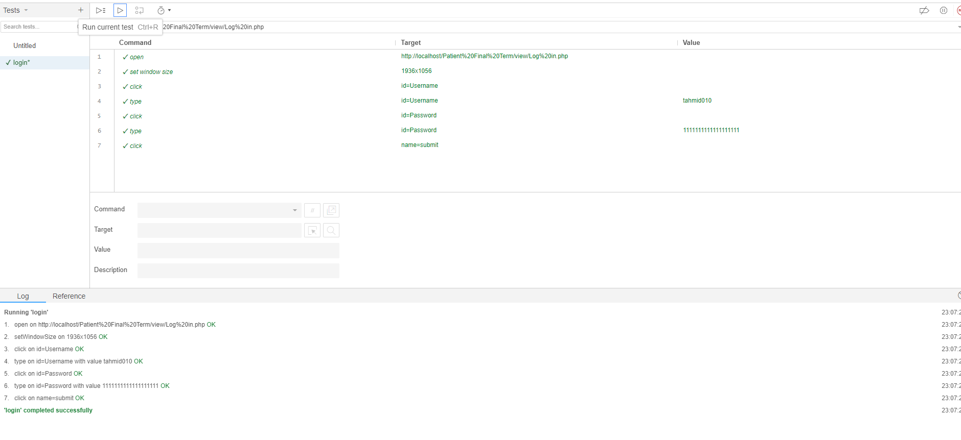

* Signup

|  |  |  |  |  |  |
| --- | --- | --- | --- | --- | --- |
| Project Name: Healthcare portal system | | | Test Designed by: Shoaib Ahamed | | |
| Test Case ID: PS_test-2 | | | Test Designed date:18/04/2024 | | |
| Test Priority (Low, Medium, High): High | | | Test Executed by: Tousif Islam | | |
| Module Name: Signup Session | | | Test Executiondate:19/04/2024 | | |
| Test Title: Provide information and register patient | | |  | | |
| Description: Test website Signup page | | |  | | |
| Precondition (If any): User must sign up if no valid username and password | | | | | |
| Test Steps | Test Data | Expected Results | | Actual Results | Status (Pass/Fail) |
| 1. Go to the website 2. Click signup 3. Enter name 4. Enter email 5. Enter address 6. Enter phone number 7. Enter gender 8. Enter DOF 9. Enter password 10. Enter confirm-password 11. Click create | Name: Md Shiraz  Email:shiraz@gmail.com  Address: Meherpur sadar  Phone number:01343435  Gender: Male  DOF:19/9/1994  Password:patient@144244  Confirm-password: patient@144244 | User should provide information into the application | | As expected, | Pass |
| Post Condition: User is validated with the provided information in database and successfully login to account. | | | | | |

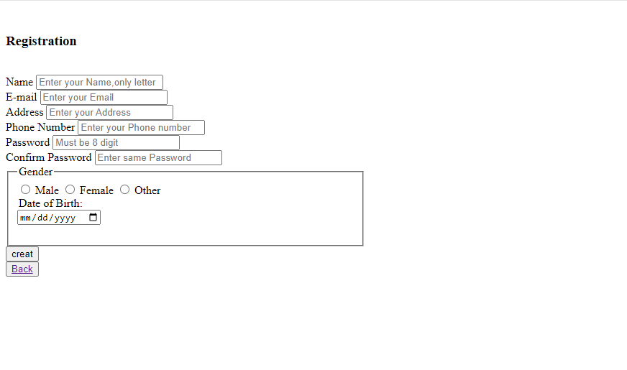

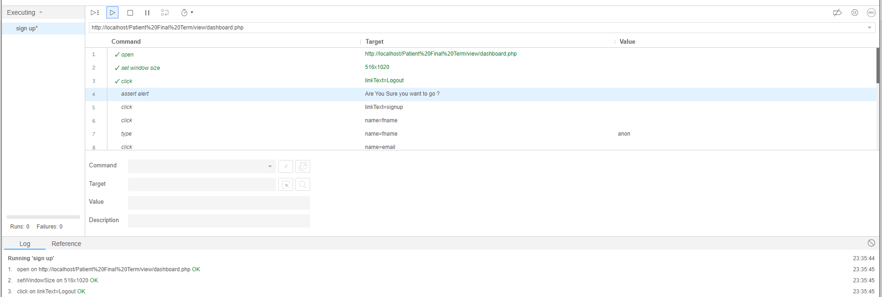

* Available list

|  |  |  |  |  |  |
| --- | --- | --- | --- | --- | --- |
| Project Name: Healthcare portal system | | | Test Designed by: Zarin Tasnim Rayta | | |
| Test Case ID: PS_test-3 | | | Test Designed date:19/04/2024 | | |
| Test Priority (Low, Medium, High): Medium | | | Test Executed by: Shoaib Ahamed | | |
| Module Name: Doctor list Session | | | Test Executiondate:20/04/2024 | | |
| Test Title: Available doctor list | | |  | | |
| Description: Doctor list will show based on specialization. | | |  | | |
| Precondition (If any): User must sign in with valid username and password | | | | | |
| Test Steps | Test Data | Expected Results | | Actual Results | Status (Pass/Fail) |
| 1. Click available doctor lists 2. Click option to select doctor 3. Click option to specialization 4. Click appointment now | Doctor name: Dr. Kamrul Hassan  Specialization: Cardiologist | User should select each section into the application | | As expected, | Pass |
| Post Condition: User can select for their perspective and choose the lists of doctor. | | | | | |

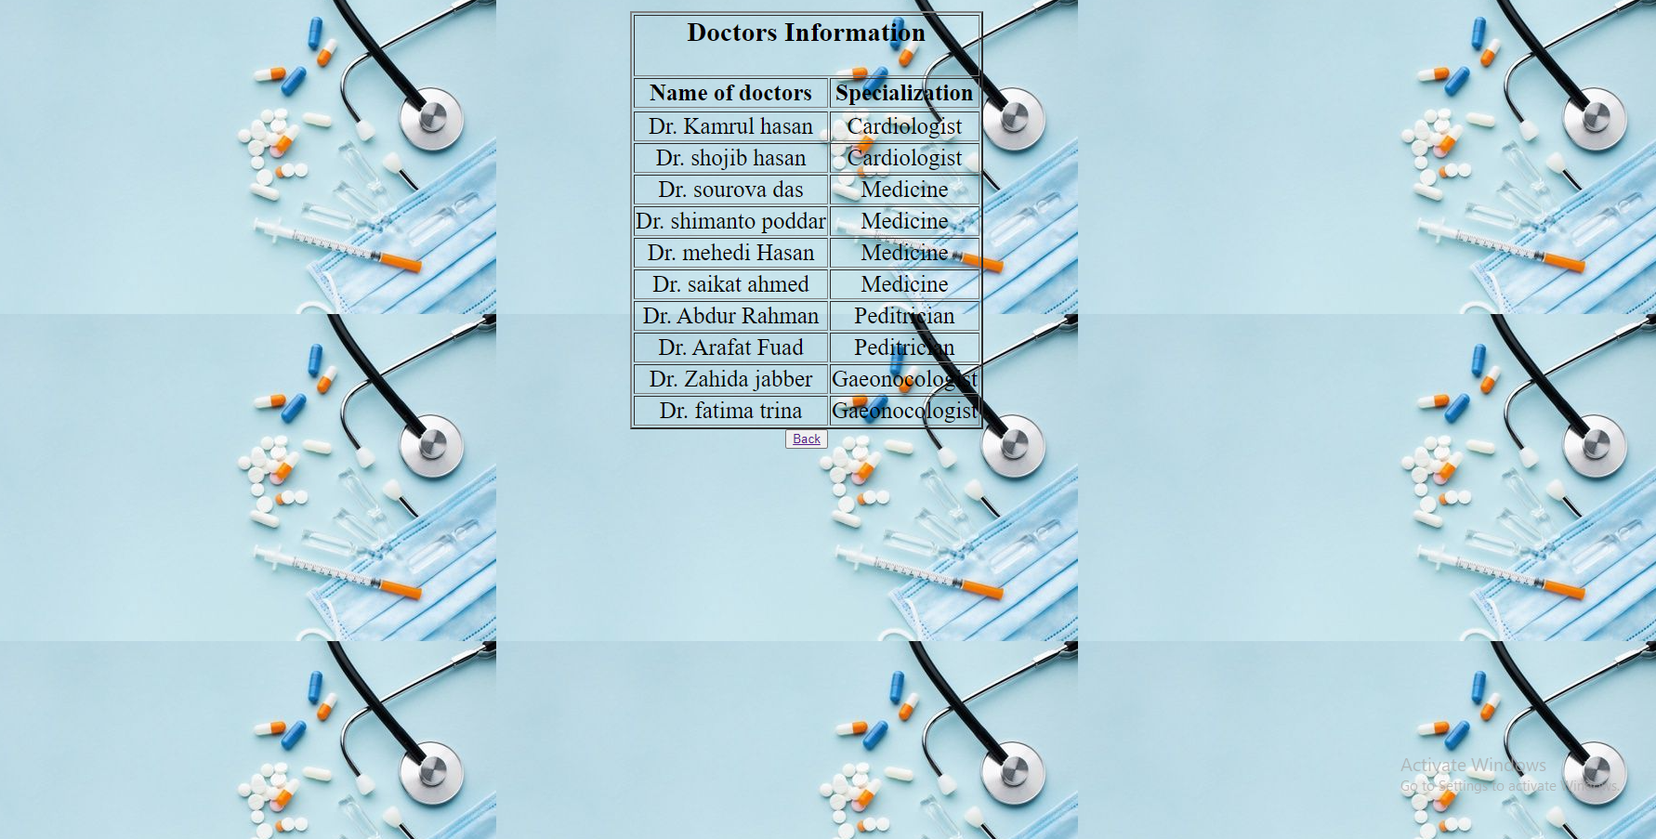

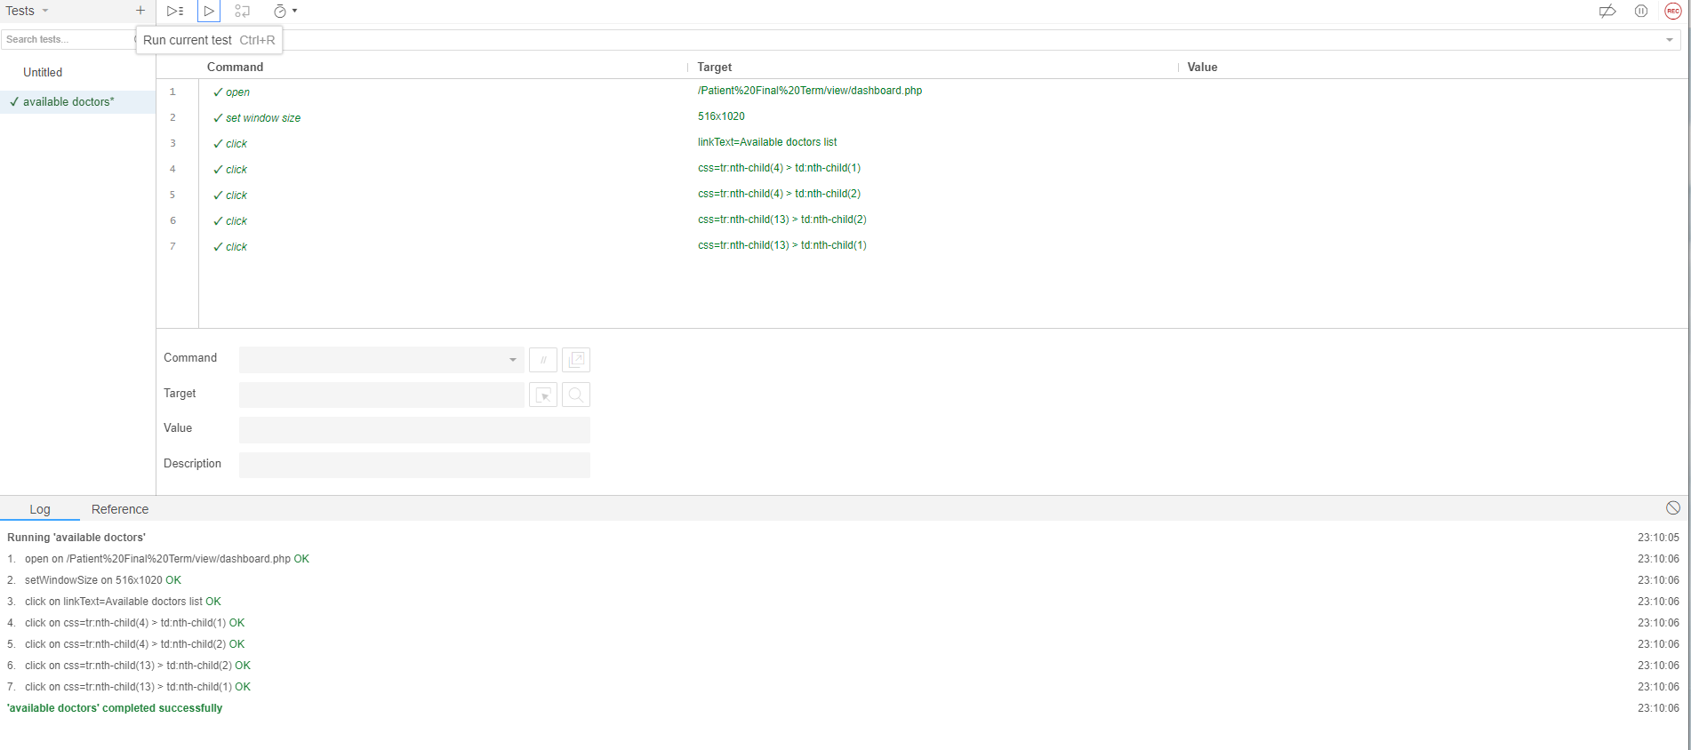

* Make the Appointments of doctor

|  |  |  |  |  |  |
| --- | --- | --- | --- | --- | --- |
| Project Name: Healthcare portal system | | | Test Designed by: Tousif Islam | | |
| Test Case ID: PS_test-4 | | | Test Designed date:20/04/2024 | | |
| Test Priority (Low, Medium, High): Low | | | Test Executed by: Shoaib Ahamed | | |
| Module Name: Appointment | | | Test Executiondate:21/04/2024 | | |
| Test Title: Appointment doctor list | | |  | | |
| Description: Test website appointments page to make booking or know thee reserved. | | |  | | |
| Precondition (If any): User have to login to the system and select doctor as per appointment. | | | | | |
| Test Steps | Test Data | Expected Results | | Actual Results | Status (Pass/Fail) |
| 1. Select the Call option 2. Click the online booking 3. Click submit | Call: 16262 or online booking to book appointment | User select to call or booking through online | | As expected, | Pass |
| Post Condition: User can now making appointment through call or online booking. | | | | | |

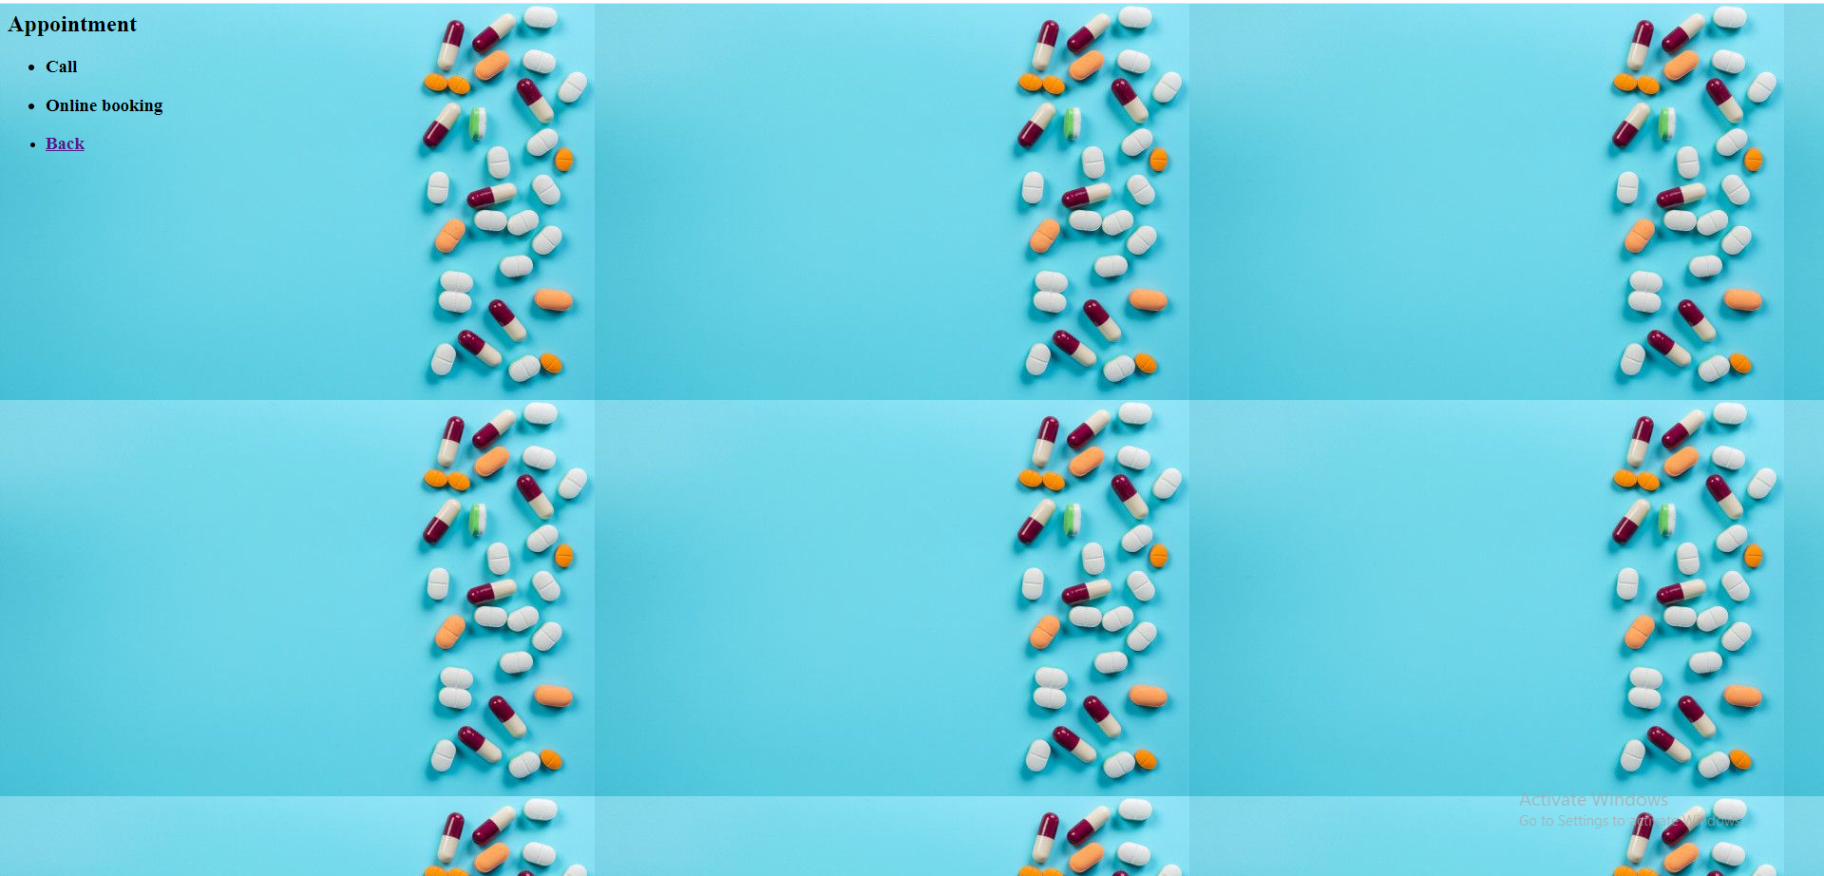

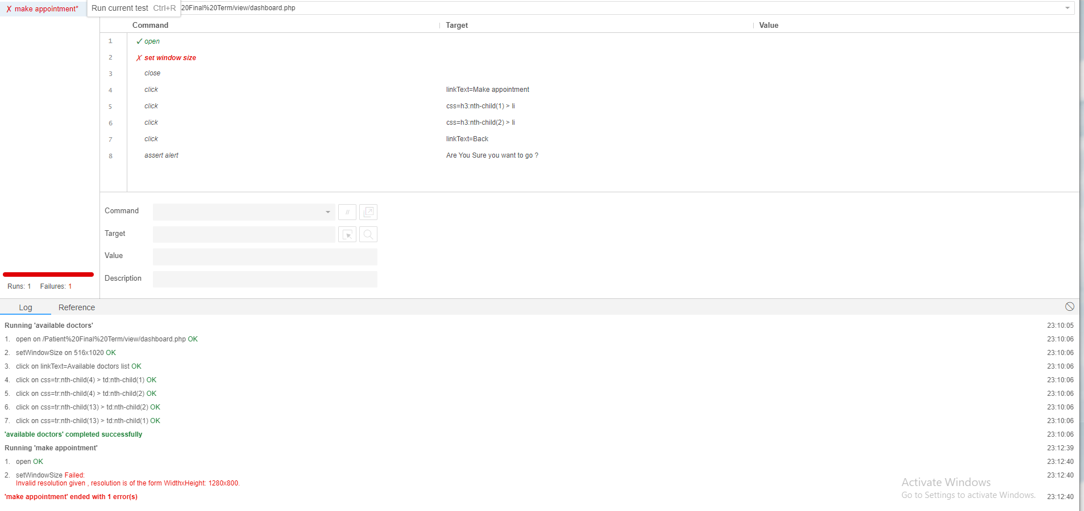

* Request for the necessary service

|  |  |  |  |  |  |
| --- | --- | --- | --- | --- | --- |
| Project Name: Healthcare portal system | | | Test Designed by: Zarin Tasnim Rayta | | |
| Test Case ID: PS_test-5 | | | Test Designed date:20/04/2024 | | |
| Test Priority (Low, Medium, High): Medium | | | Test Executed by: Tousif Islam | | |
| Module Name: Services | | | Test Executiondate:21/04/2024 | | |
| Test Title: Request for the service | | |  | | |
| Description: User can request for the service they want. | | |  | | |
| Precondition (If any): User have to check the availability of service | | | | | |
| Test Steps | Test Data | Expected Results | | Actual Results | Status (Pass/Fail) |
| 1. Select the emergency service 2. Select home service 3. Select ambulance hotline |  | User select to call or get services that is available | | As expected, | Pass |
| Post Condition: User can get the services through requesting. | | | | | |



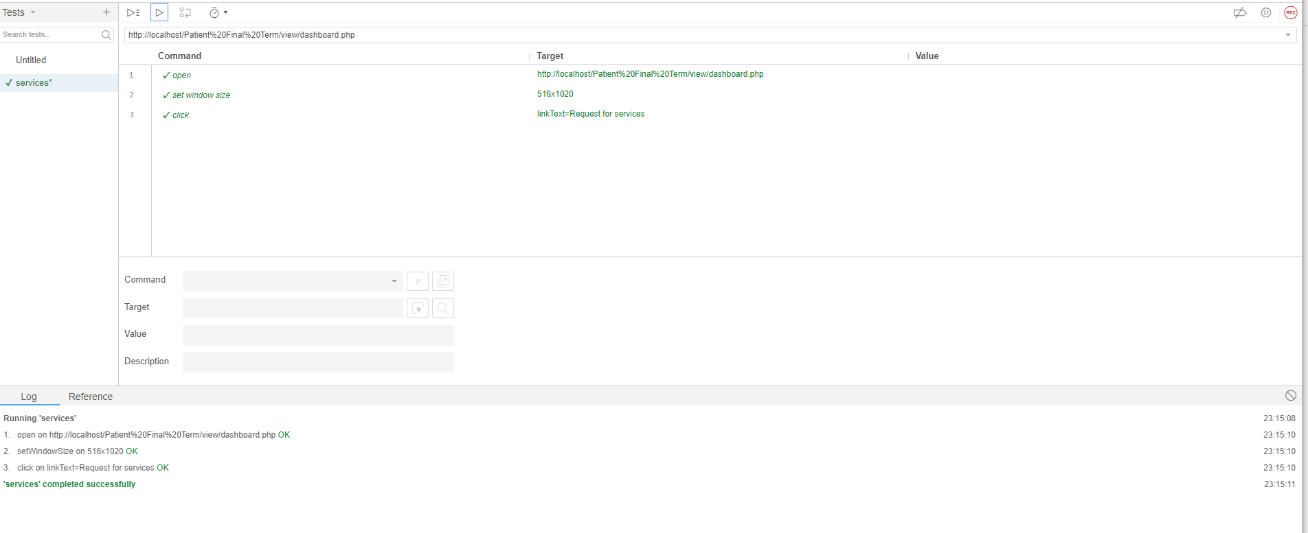

* Payment history

|  |  |  |  |  |  |
| --- | --- | --- | --- | --- | --- |
| Project Name: Healthcare portal system | | | Test Designed by:Shoaib Ahamed | | |
| Test Case ID: PS_test-6 | | | Test Designed date:20/04/2024 | | |
| Test Priority (Low, Medium, High): High | | | Test Executed by: Zarin Tasnim Rayta | | |
| Module Name: Payment | | | Test Executiondate:21/04/2024 | | |
| Test Title: Check payments | | |  | | |
| Description: User can payment through online. | | |  | | |
| Precondition (If any): User have to appointment or booking the slot. | | | | | |
| Test Steps | Test Data | Expected Results | | Actual Results | Status (Pass/Fail) |
| 1. Select digital payment 2. Select by cash payment 3. Optional for late payment |  | Total amount will show and the invoice can printed | | As expected, | Pass |
| Post Condition: User will be able to see all payment history from account creation and new payment will automatically be added to payment history. | | | | | |



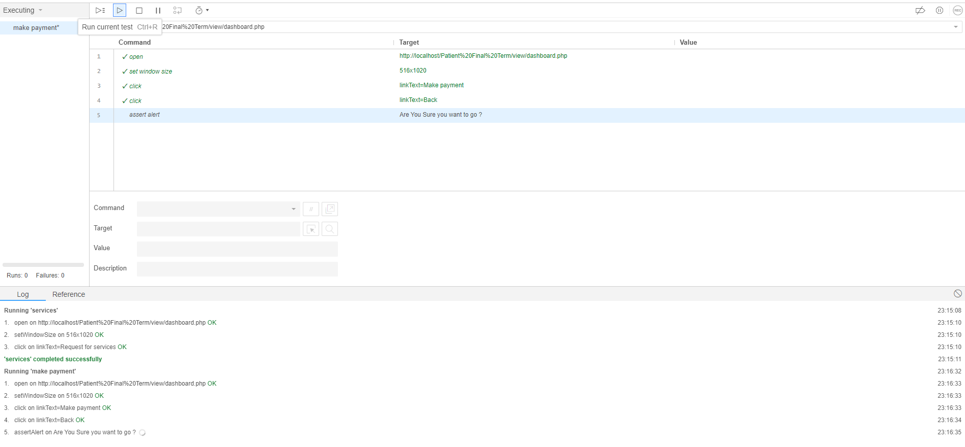

* Complain box

|  |  |  |  |  |  |
| --- | --- | --- | --- | --- | --- |
| Project Name: Healthcare portal system | | | Test Designed by: Tousif Islam | | |
| Test Case ID: Box_test-7 | | | Test Designed date:21/04/2024 | | |
| Test Priority (Low, Medium, High): Low | | | Test Executed by: Shoaib Ahamed | | |
| Module Name: Complain | | | Test Executiondate:22/04/2024 | | |
| Test Title: Complain box | | |  | | |
| Description: Can complain about any uncertain situations. | | |  | | |
| Precondition (If any): | | | | | |
| Test Steps | Test Data | Expected Results | | Actual Results | Status (Pass/Fail) |
| 1. Write message about to complain 2. Click to Submit 3. Click to reset message |  | Message can be written or reset | | As expected, | Pass |
| Post Condition: User will be aware and able to see the complain details and the action that is taken. | | | | | |

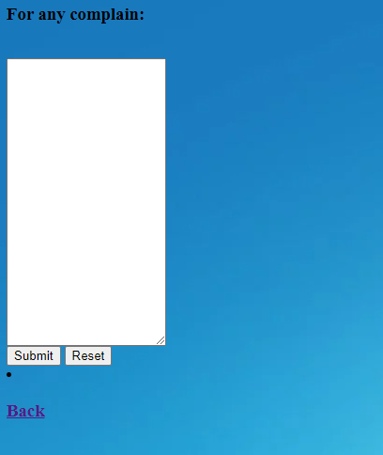

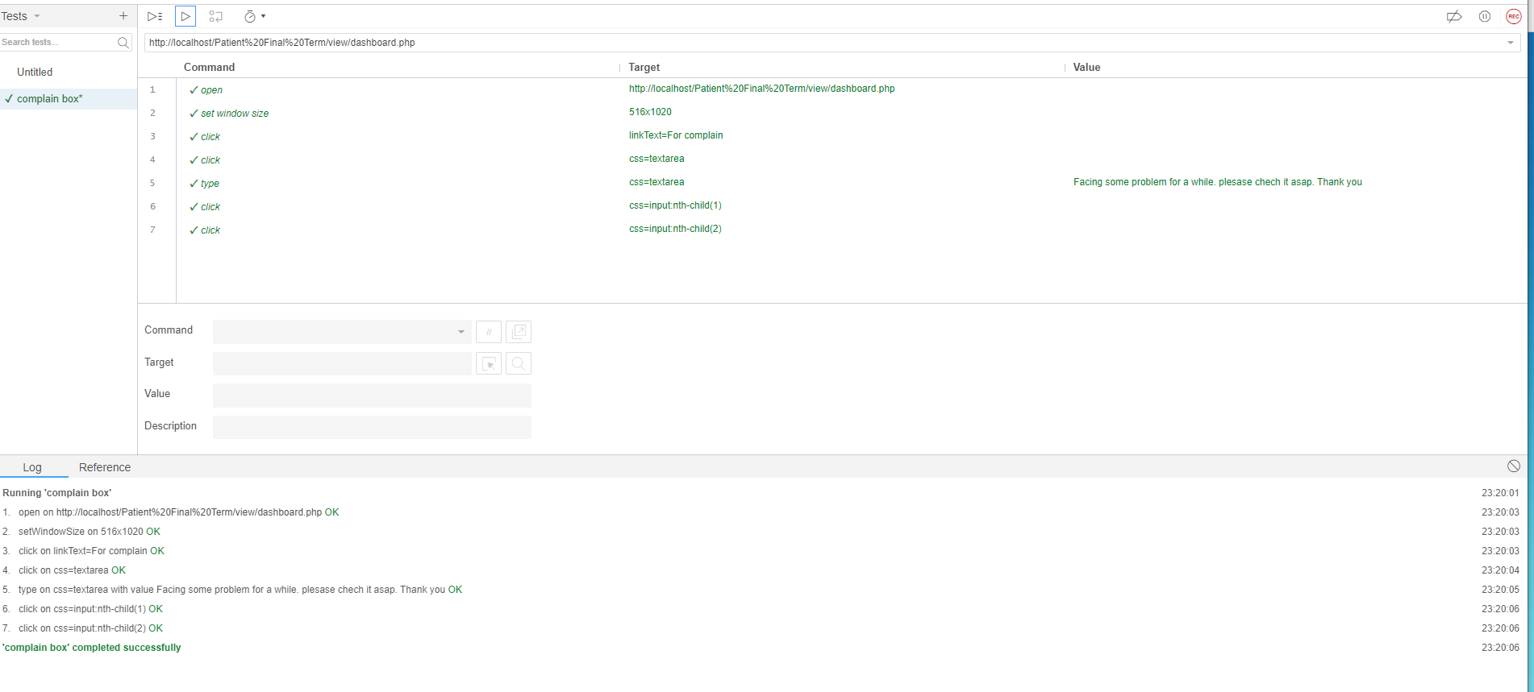

* Medicine

|  |  |  |  |  |  |
| --- | --- | --- | --- | --- | --- |
| Project Name: Healthcare portal system | | | Test Designed by: Zarin Tasnim Rayta | | |
| Test Case ID: PS_test-8 | | | Test Designed date:21/04/2024 | | |
| Test Priority (Low, Medium, High): Medium | | | Test Executed by: Shoaib Ahamed | | |
| Module Name: Medication | | | Test Executiondate:22/04/2024 | | |
| Test Title: Medicine for patient | | |  | | |
| Description: Doctor provided medicine. | | |  | | |
| Precondition (If any): User have to appointment to doctor. | | | | | |
| Test Steps | Test Data | Expected Results | | Actual Results | Status (Pass/Fail) |
| 1. Enter the prescription number 2. Enter the serial number of patient 3. Check existing or new patient 4. Click submit | Prescription:PSD101  Serial number: 27  Patient history: New | User will get the prescriptions about medication | | As expected, | Pass |
| Post Condition: Doctor will provide medicine to the patient who have registered or booked. | | | | | |

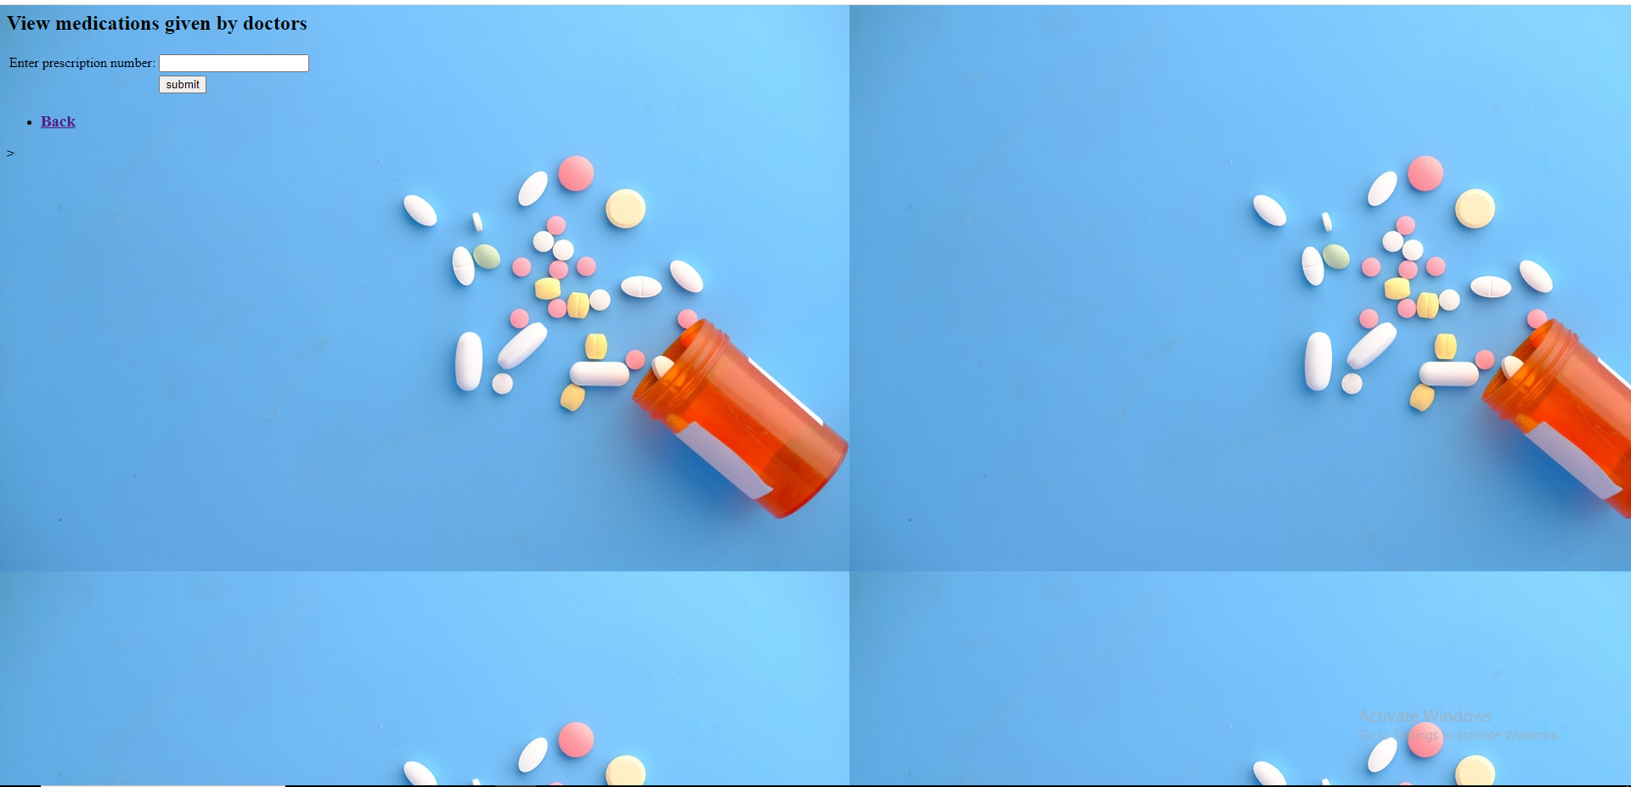

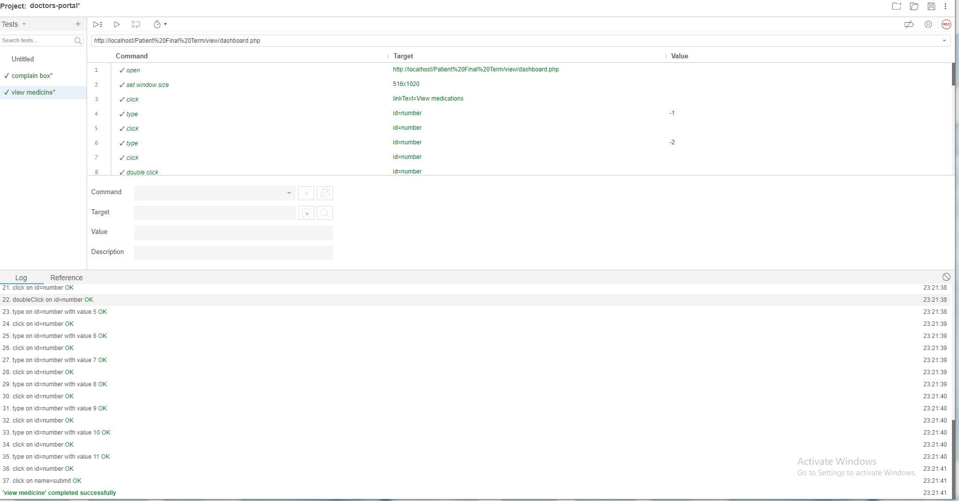

* Transaction history

|  |  |  |  |  |  |
| --- | --- | --- | --- | --- | --- |
| Project Name: Healthcare portal system | | | Test Designed by: Shoaib Ahamed | | |
| Test Case ID: PS_test-9 | | | Test Designed date:21/04/2024 | | |
| Test Priority (Low, Medium, High): High | | | Test Executed by: Zarin Tasnim Rayta | | |
| Module Name: Transaction history | | | Test Executiondate:22/04/2024 | | |
| Test Title: Tests the transaction history | | |  | | |
| Description: Transfer money and the history | | |  | | |
| Precondition (If any): | | | | | |
| Test Steps | Test Data | Expected Results | | Actual Results | Status (Pass/Fail) |
| 1. Enter the bill number 2. Enter the total amount 3. Click accepted | Bill no: BTVS16678  Total amount: 1700 | Transfer money in a online | | As expected, | Pass |
| Post Condition: User can view the history about the whole transaction. | | | | | |

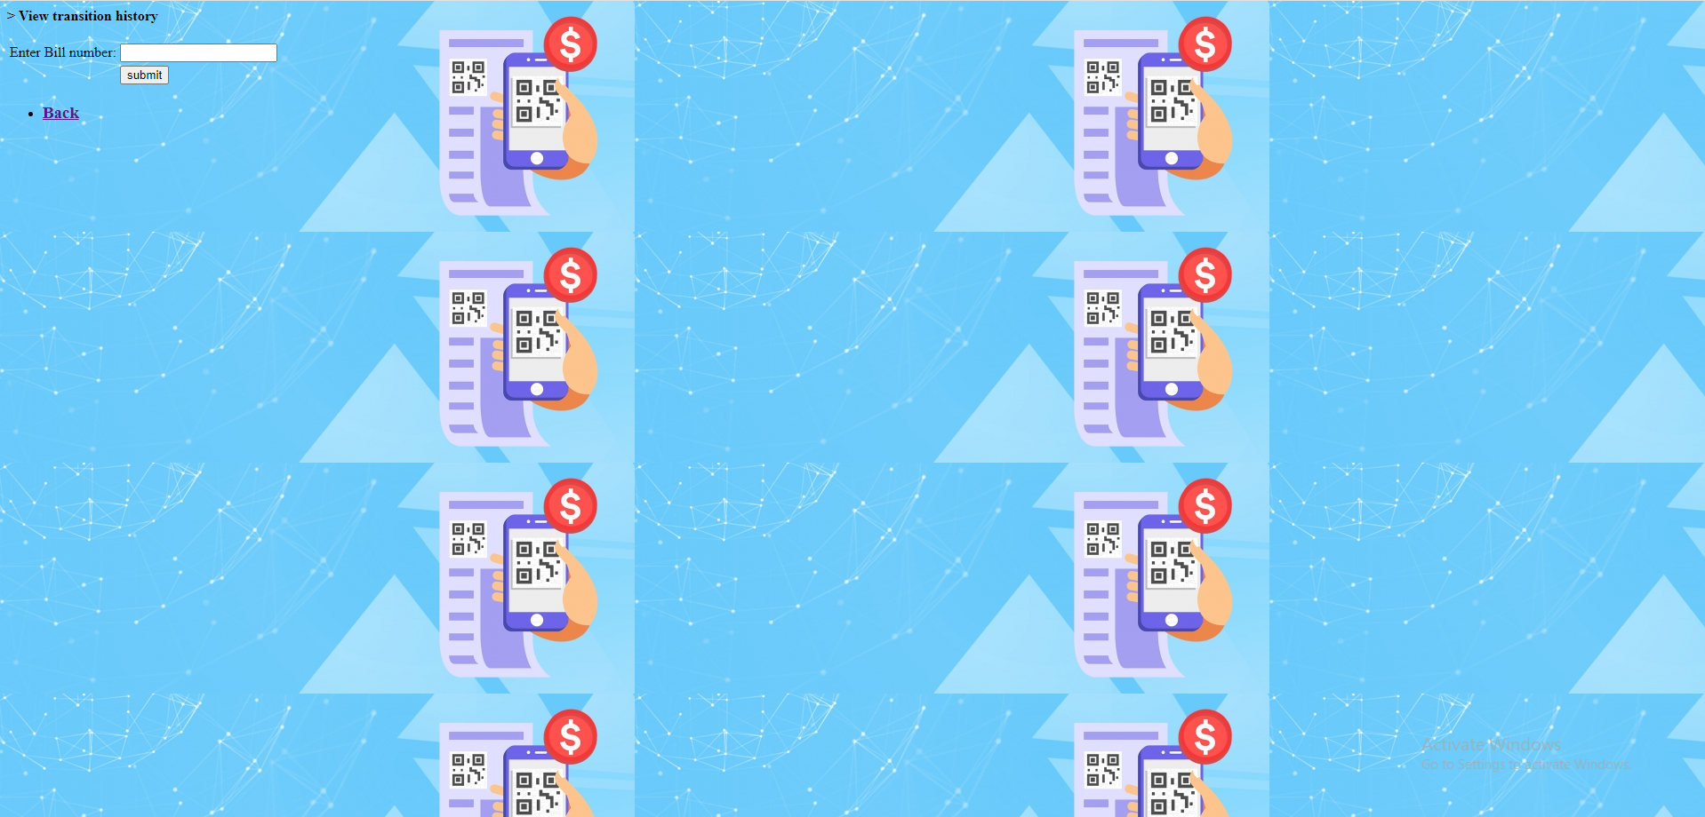

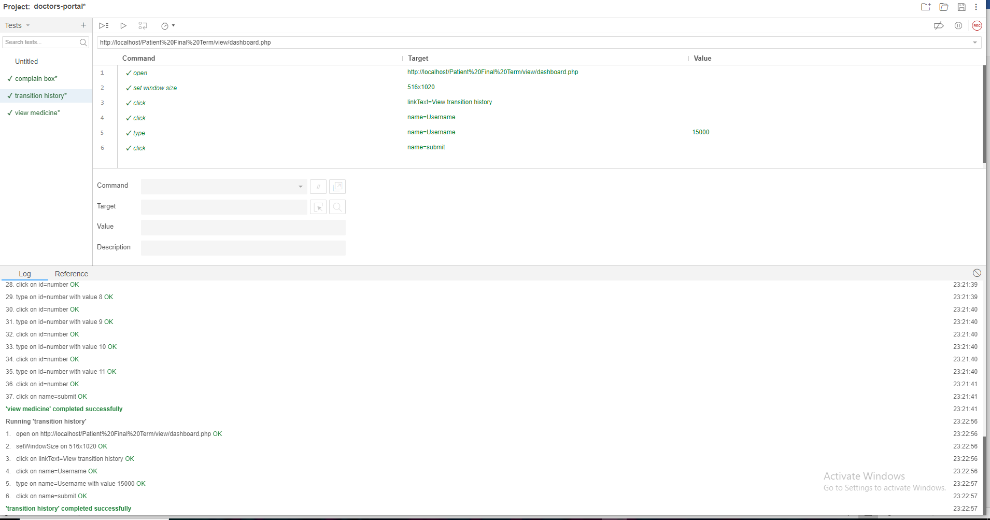

* Contact with healthcare

|  |  |  |  |  |  |
| --- | --- | --- | --- | --- | --- |
| Project Name: Healthcare portal system | | | Test Designed by:Tousif Islam | | |
| Test Case ID: PS_test-10 | | | Test Designed date:22/04/2024 | | |
| Test Priority (Low, Medium, High): Low | | | Test Executed by:Zarin Tasnim Rayta | | |
| Module Name: Contact info | | | Test Execution date:23/04/2024 | | |
| Test Title: Contact with healthcare | | |  | | |
| Description: Transfer money and the history | | |  | | |
| Precondition (If any): | | | | | |
| Test Steps | Test Data | Expected Results | | Actual Results | Status (Pass/Fail) |
| 1. Select call 2. Enter email to healthcare 3. Click submit | Email:managerment@244gmail.com | Received email address | | As expected, | Pass |
| Post Condition: User can contact with healthcare and can identify their questions. | | | | | |

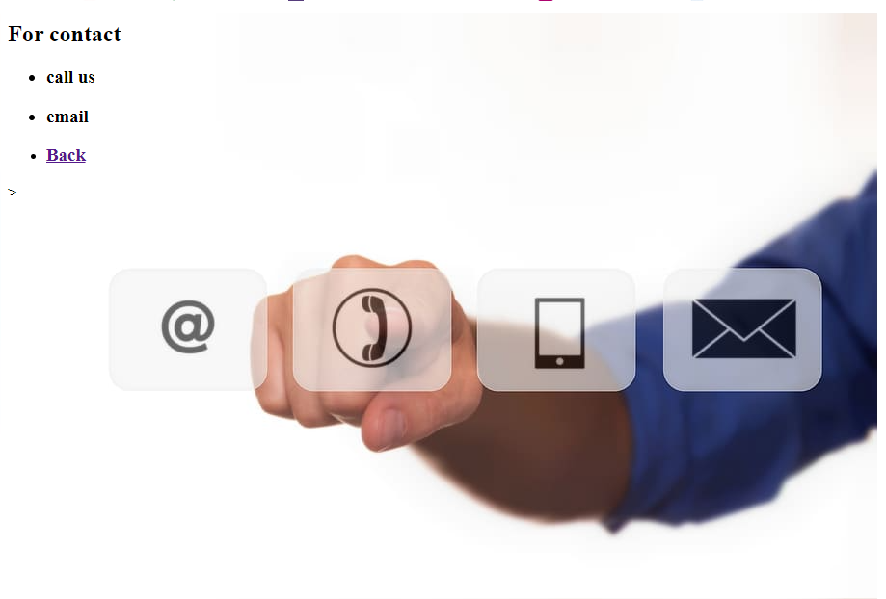

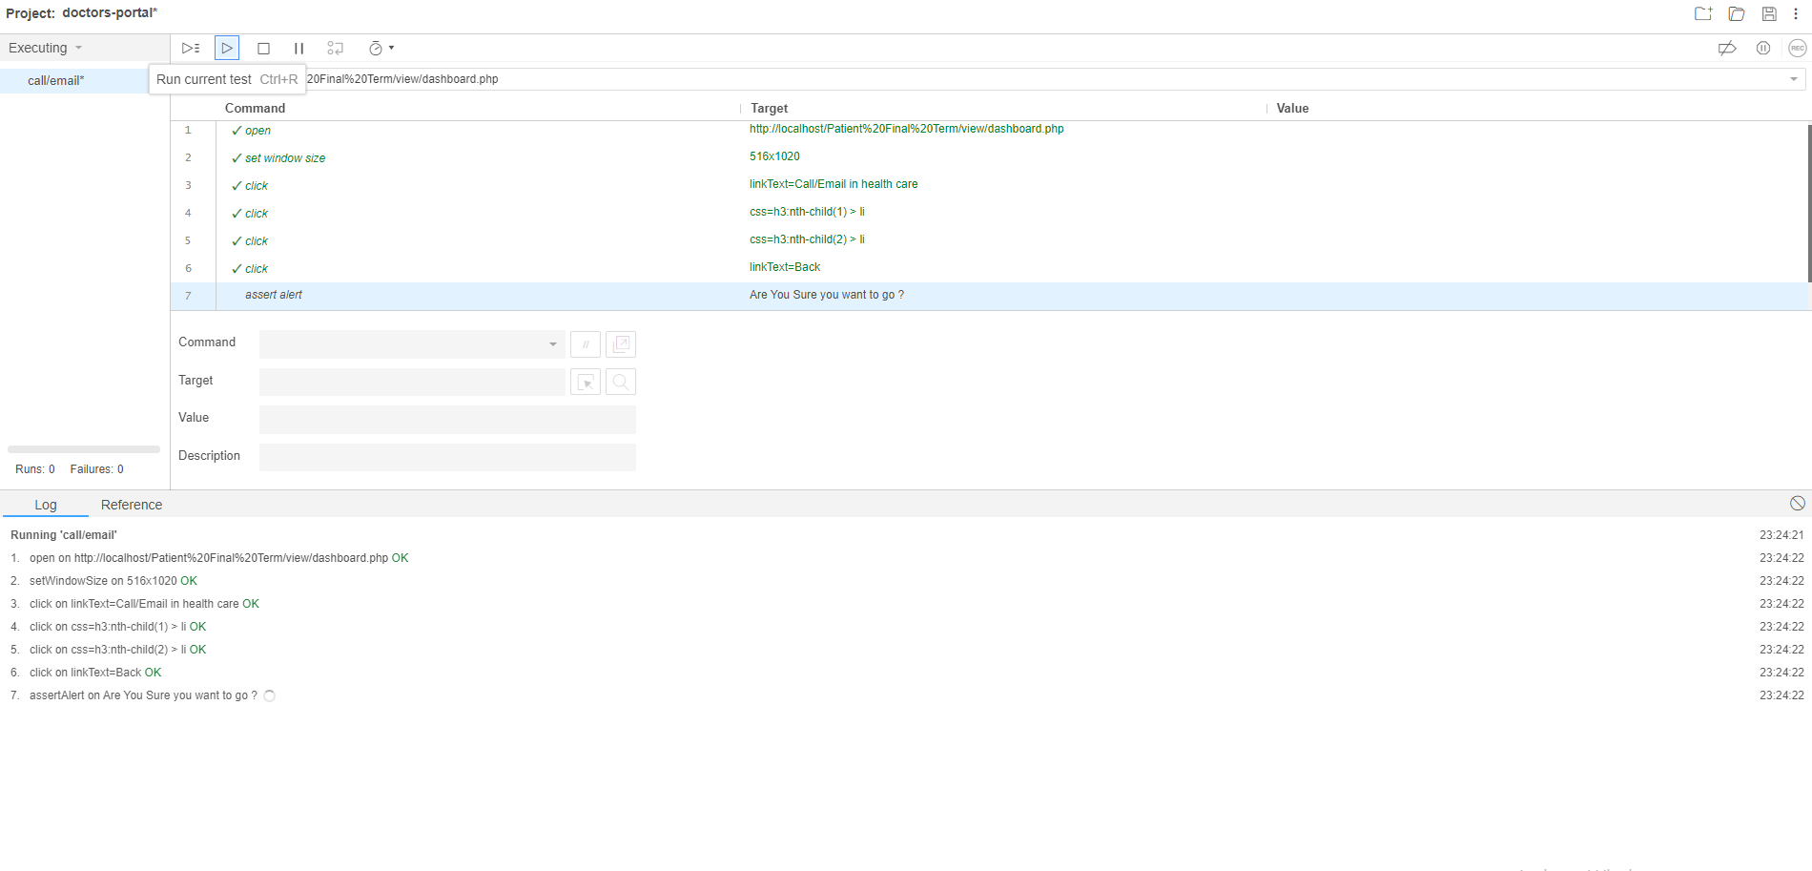

* Review system

|  |  |  |  |  |  |
| --- | --- | --- | --- | --- | --- |
| Project Name: Healthcare portal system | | | Test Designed by:Zarin Tasnim Rayta | | |
| Test Case ID: PS_test-11 | | | Test Designed date:22/04/2024 | | |
| Test Priority (Low, Medium, High): Low | | | Test Executed by: Tousif Islam | | |
| Module Name: Review | | | Test Executiondate:23/04/2024 | | |
| Test Title: Review to the healthcare | | |  | | |
| Description: Review if service quality is good to suggest | | |  | | |
| Precondition (If any): | | | | | |
| Test Steps | Test Data | Expected Results | | Actual Results | Status (Pass/Fail) |
| 1. Enter message 2. Click reset 3. Click submit | Message: According to the package of healthcare the services are good enough to suggest | Received email address | | As expected, | Pass |
| Post Condition: User can review based on services. | | | | | |



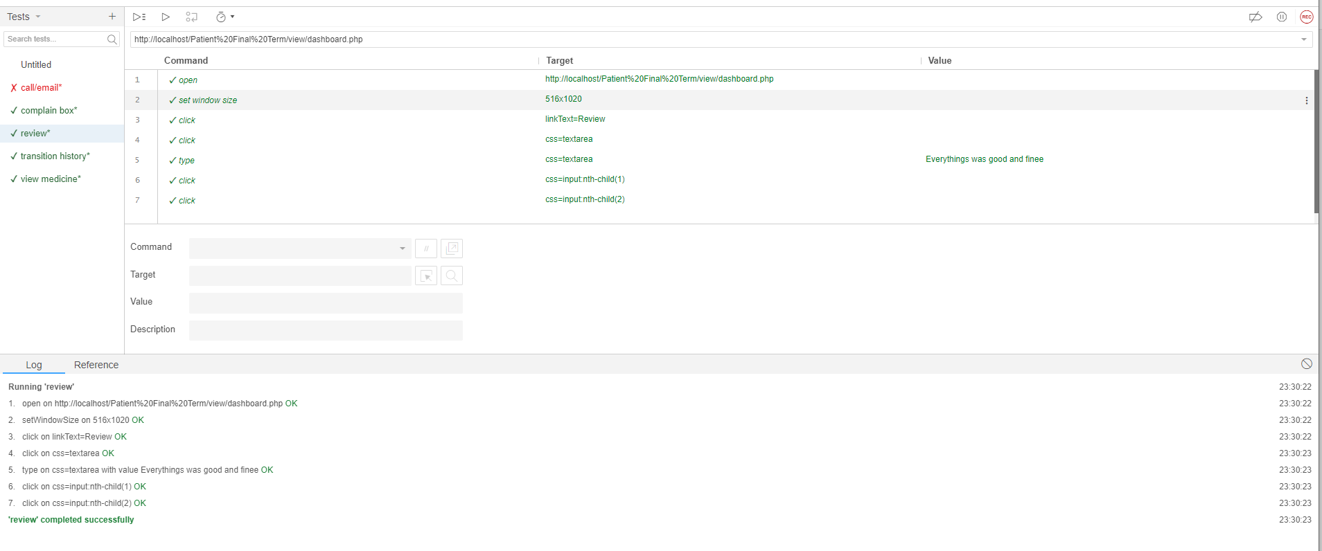

* Logout

|  |  |  |  |  |  |
| --- | --- | --- | --- | --- | --- |
| Project Name: Healthcare portal system | | | Test Designed by:Shoaib Ahamed | | |
| Test Case ID: PS_test-12 | | | Test Designed date:22/04/2024 | | |
| Test Priority (Low, Medium, High): High | | | Test Executed by: Tousif Islam | | |
| Module Name: Logout | | | Test Executiondate:23/04/2024 | | |
| Test Title: Logout to the system | | |  | | |
| Description: Log out if everything has done | | |  | | |
| Precondition (If any): Need to login first | | | | | |
| Test Steps | Test Data | Expected Results | | Actual Results | Status (Pass/Fail) |
| 1. Click Log out |  | Logging out successfully | | As expected, | Pass |
| Post Condition: User can Logout when they have done with their work. | | | | | |

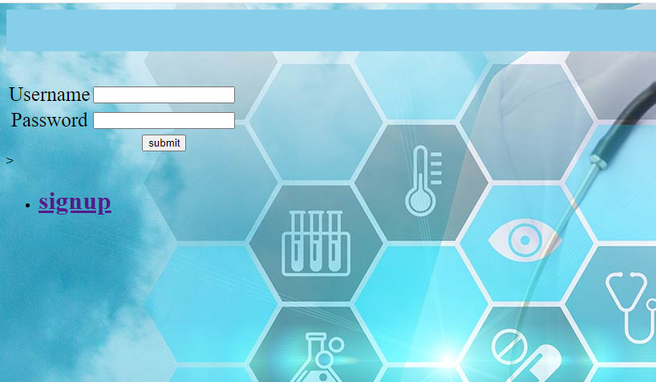

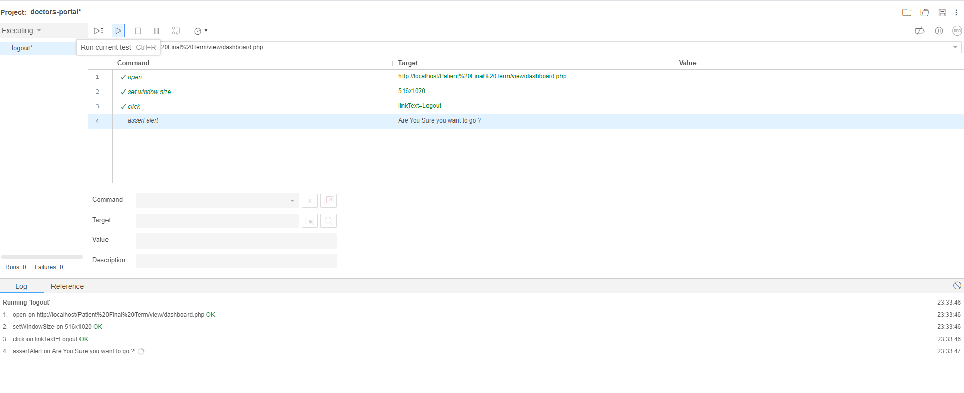

# ITEM PASS/FAIL CRITERIA

95% tests were executed and many of them seem to have passed. Based on the analysis, it can be concluded that the project does not contain any severe anomalies. The detected defects are primarily related to logic errors or code errors. Further analysis and resolution of these defects are recommended before the system is shipped to users. This can be achieved by collaborating with the development team, conducting necessary regression tests, and performing unit tests as required. This test summary report provides an overview of the test results and defects identified during the testing phase. However, it does not provide an in-depth analysis of each individual test case or defect. Further investigation and collaboration with the development team will be necessary to address and resolve the identified defects effectively.

# TEST DELIVERABLES

**Phases of Testing Deliverables:**

|  |  |
| --- | --- |
| Items Name | Description |
| Acceptance test plan | A document that describes the methodology, parameters, resources, timetable, and standards for acceptance testing. It outlines the process by which end users will verify that the system satisfies their needs and expectations. |
| System/Integration test plan | It describes the general testing strategy for confirming how system components interact with one another. |
| Unit test plans/turnover documentation | Documents outlining the strategy for testing individual units. |
| Screen prototypes | Prototypes help stakeholders visualize the end product before development is complete. |
| Report mock-ups | Mock-ups help stakeholders understand how data will be presented in the final reports. |
| Defect/Incident reports and summaries | Records describing any errors or mishaps that occurred during testing, together with information on how to replicate them, how serious they are, and how to fix them. An overview of the overall defect and incident status is given by summaries. |
| Test logs and turnover reports | Records of test activities, including test execution details, results, and any issues encountered |

# STAFFING AND TRAINING NEEDS

This section outlines how to approach staffing and training the test roles for the project. Staffing is fixed for the duration of this project. It is likely most of the staff will assume some testing role that will be discuss. It needs to involve evaluating and addressing the personnel and skill requirements of an organization. Building a projects that includes a several things. Because a team can be successful when they have the correct workforce and training. So, trained well the who are the associated with this activity.

We will need to provide the basic training to get idea. Many employees will get help for this and they can improve their skills based on training program. It can enhance the capabilities for the organizational team.

It includes assessing the current workforce of our tester, developer team, they can be identifying their gaps skills. We also need to implementing the recruitment strategies, and developing training programs to enhance employee capabilities.

Our goal is to align the workforce with organizational goals, ensure skill adequacy, and promote continuous improvement through training and development initiatives.

# RESPONSIBILITIES

|  |  |  |  |  |  |
| --- | --- | --- | --- | --- | --- |
|  | TM | PM | Dev  Team | Test  Team | Client |
| Acceptance test documentation &  Execution | X | X |  | X | X |
| System/Integration test documentation &  Execution | X |  | X | X |  |
| Unit test documentation & Execution | X |  | X | X |  |
| System design reviews | X | X | X | X | X |
| Detail design reviews | X | X | X | X |  |
| Test procedures and rules | X | X | X | X |  |
| Screen and report prototype reviews |  |  | X | X | X |
| Change control and regression testing | X | X | X | X | X |

# TESTING SCHEDULE

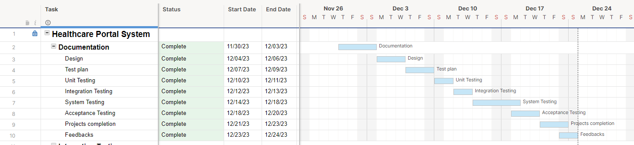

# PLANNING RISKS AND CONTINGENCIES

|  |  |  |  |
| --- | --- | --- | --- |
| **Risk** | **Probability** | **Type of Risks** | **Contingencies** |
| Unable to acquire the necessary number of skilled person | 30% | Resource problems | Determine essential personnel who can temporarily cover open positions or divide the workload among current employees. |
| The person who will joining need to proper train up | 55% | Cross-Training required | Cross-train existing team members to enhance flexibility. |
| Communicate to the clients due to unable to have resource short | 60% | Communication Plan success | Establish clear communication channels with the client to communicate potential delays. Keep the client informed about the resource shortage and efforts to mitigate its impact. |
| In meantime project need to handle by team so avoid delay and recruit | 30% | Continuous Recruitment processes | Initiate continuous recruitment efforts to promptly fill the vacant positions. Regularly update the recruitment status with the project team. |
| Conducts and schedule meeting to analysis risks | 5% | Risk Review Meetings analysis | Conduct regular risk review meetings to reassess the impact and adjust contingency plans. |
| Turnover | 5% | Personnel | Testers will work in pairs on components. If a single member of the team decides to leave, a secondary testing with the knowledge of the component will still be able to train a new tester or finish the work. Schedule must be adjusted accordingly |

# APROVALS

|  |  |
| --- | --- |
| Project Sponsor | Tousif Islam |
| Development Management | Shoaib Ahamed |
| EDI Project Manager | Zarin Tasnim Rayta |
| RS Test Manager | Shoaib Ahamed |
| RS Development Team Manager | Tousif Islam |
| Reassigned Sales | Zarin Tasnim Rayta |
| Order Entry EDI Team Manager | Tousif Islam |